Digital-Nurture-5.0-Deep-Skilling-Java-hands-on-exercise WEEK 1

Exercise 1: Implementing the Singleton Pattern
Scenario:
You need to ensure that a logging utility class in your application has only one instance throughout the application lifecycle to ensure consistent logging.
Steps:
- Create a New Java Project:
  - Create a new Java project named SingletonPatternExample.
- Define a Singleton Class:
  - Create a class named Logger that has a private static instance of itself.
  - Ensure the constructor of Logger is private.
  - Provide a public static method to get the instance of the Logger class.
- Implement the Singleton Pattern:
  - Write code to ensure that the Logger class follows the Singleton design pattern.
- Test the Singleton Implementation:
  - Create a test class to verify that only one instance of Logger is created and used across the application.
OUTPUT :
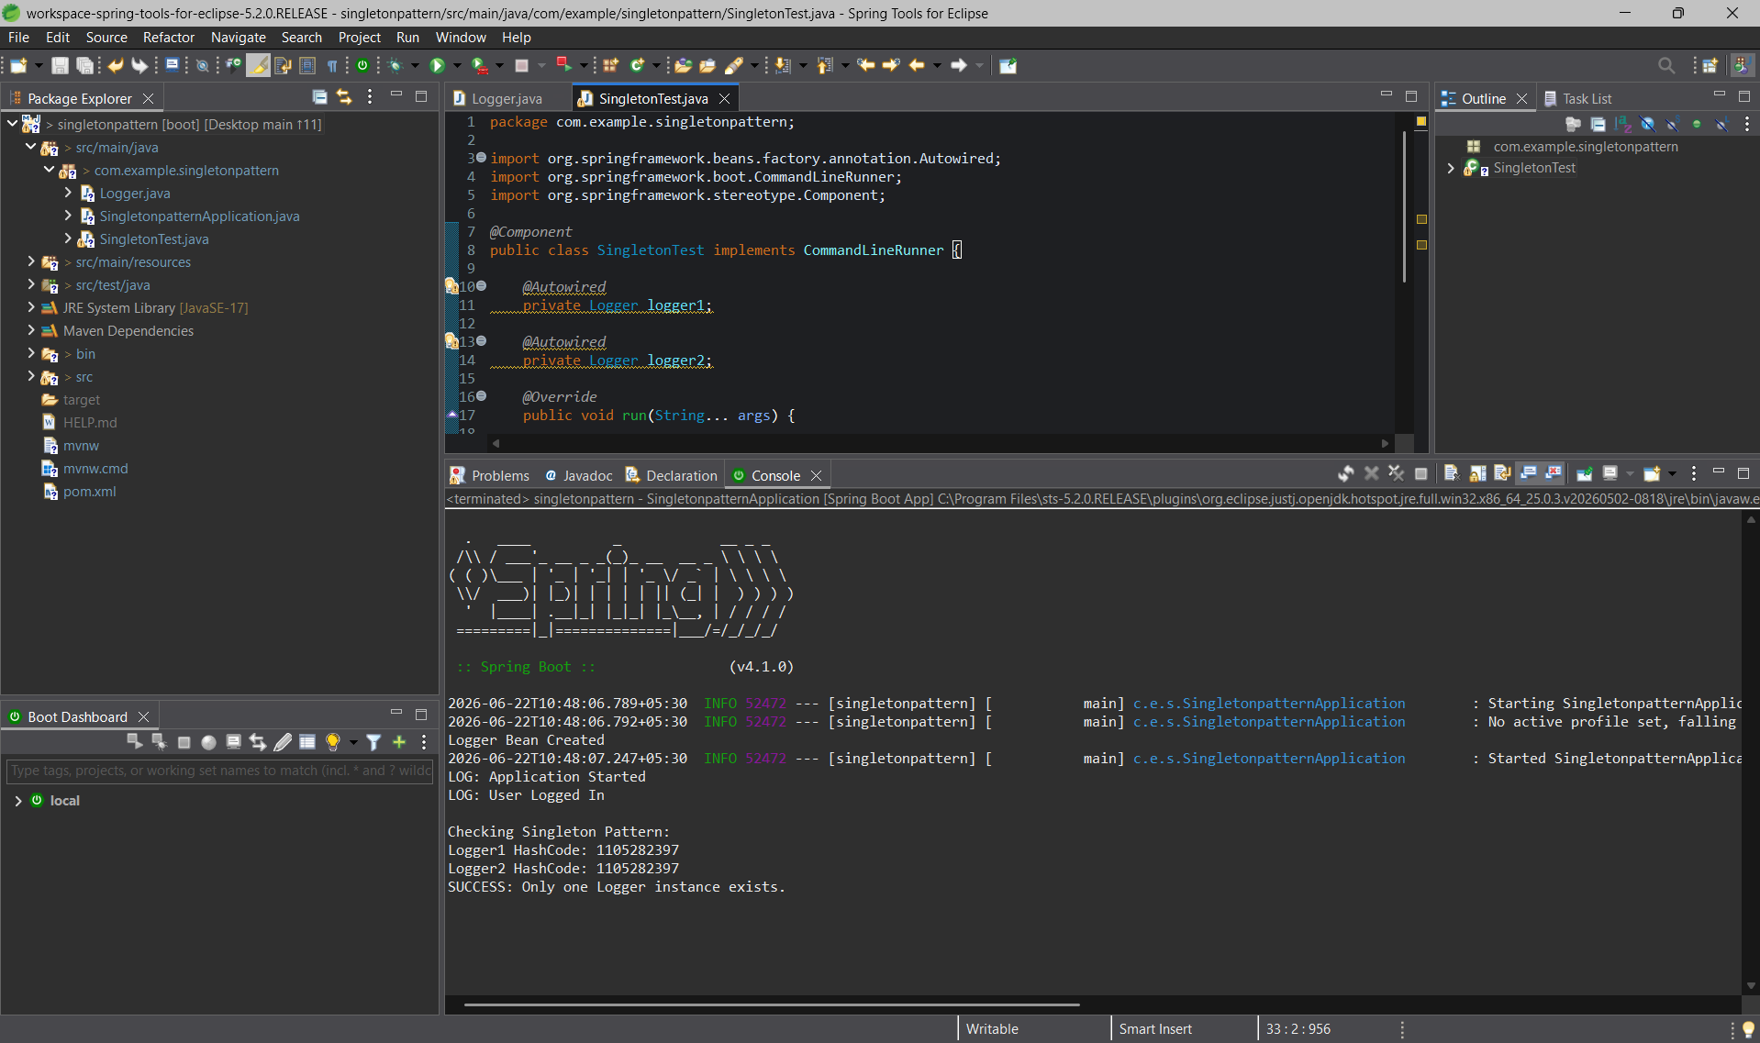

Exercise 2: Implementing the Factory Method Pattern
Scenario:
You are developing a document management system that needs to create different types of documents (e.g., Word, PDF, Excel). Use the Factory Method Pattern to achieve this.
Steps:
- Create a New Java Project:
  - Create a new Java project named FactoryMethodPatternExample.
- Define Document Classes:
  - Create interfaces or abstract classes for different document types such as WordDocument, PdfDocument, and ExcelDocument.
- Create Concrete Document Classes:
  - Implement concrete classes for each document type that implements or extends the above interfaces or abstract classes.
- Implement the Factory Method:
  - Create an abstract class DocumentFactory with a method createDocument().
  - Create concrete factory classes for each document type that extends DocumentFactory and implements the createDocument() method.
- Test the Factory Method Implementation:
  - Create a test class to demonstrate the creation of different document types using the factory method.

OUTPUT :

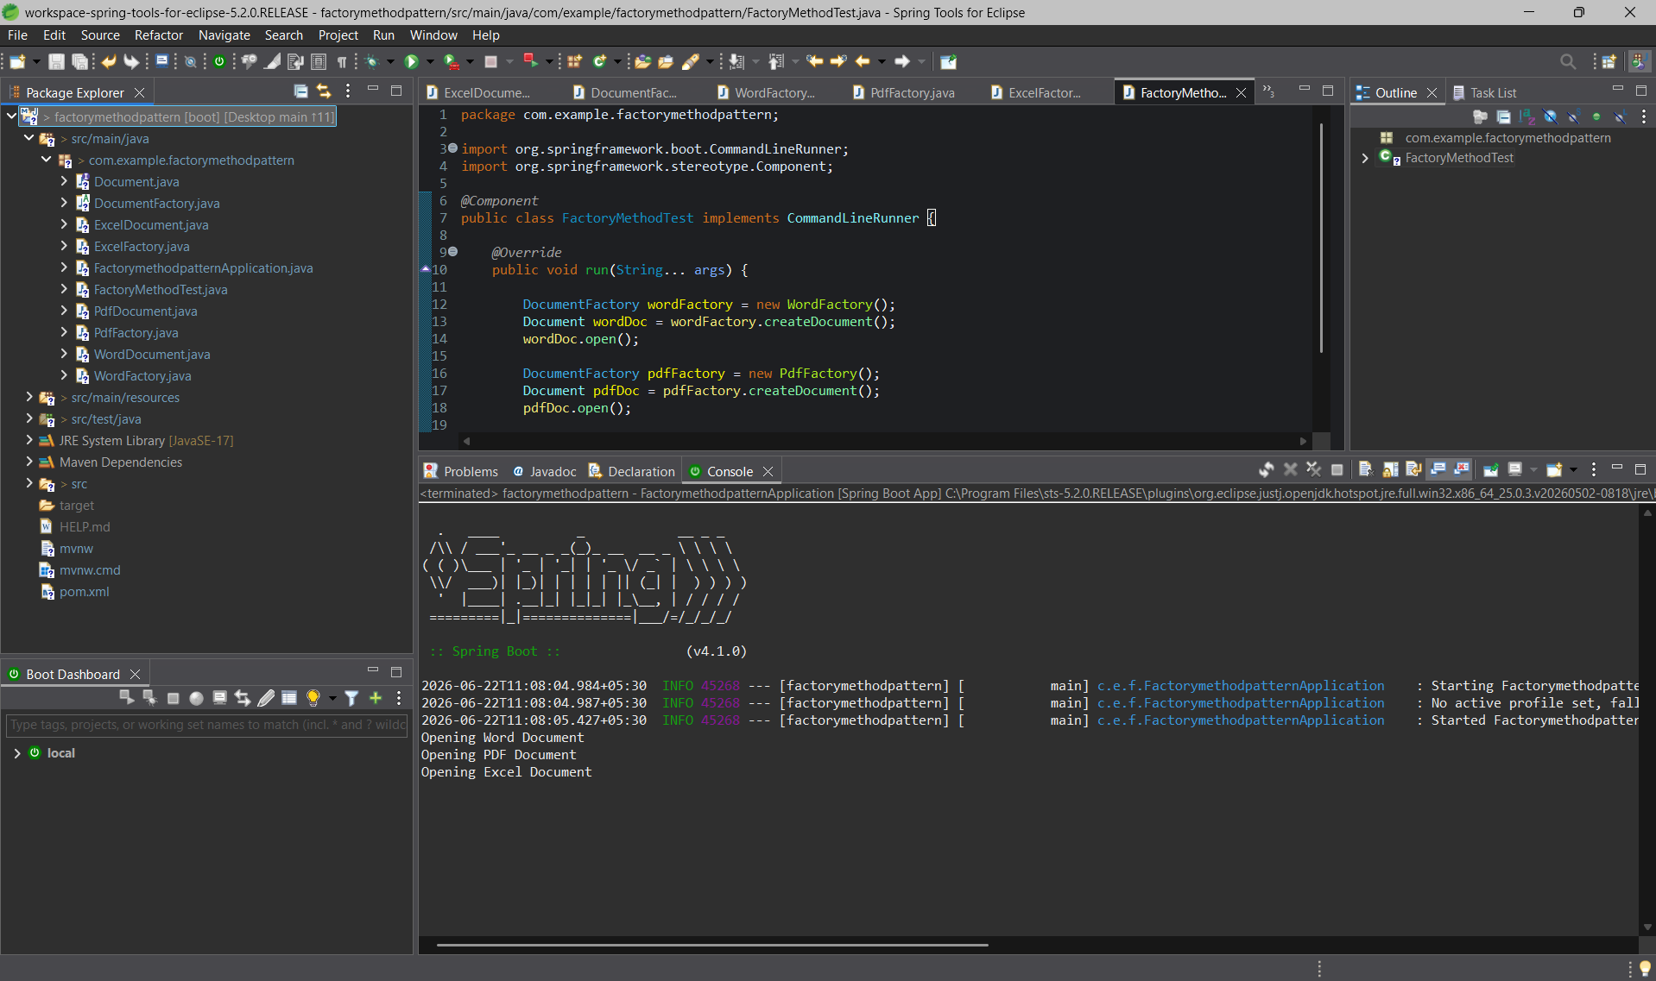

Exercise 3: Implementing the Builder Pattern
Scenario:
You are developing a system to create complex objects such as a Computer with multiple optional parts. Use the Builder Pattern to manage the construction process.
Steps:
- Create a New Java Project:
  - Create a new Java project named BuilderPatternExample.
- Define a Product Class:
  - Create a class Computer with attributes like CPU, RAM, Storage, etc.
- Implement the Builder Class:
  - Create a static nested Builder class inside Computer with methods to set each attribute.
  - Provide a build() method in the Builder class that returns an instance of Computer.
- Implement the Builder Pattern:
  - Ensure that the Computer class has a private constructor that takes the Builder as a parameter.
- Test the Builder Implementation:
  - Create a test class to demonstrate the creation of different configurations of Computer using the Builder pattern.

OUTPUT :
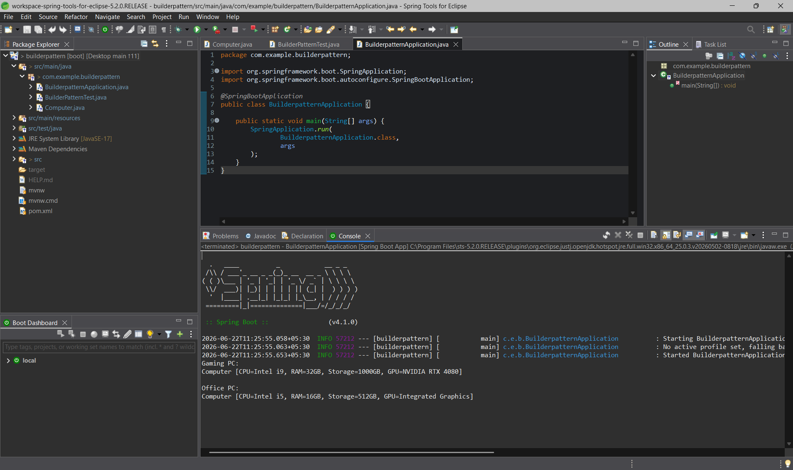

Exercise 4: Implementing the Adapter Pattern
Scenario:
You are developing a payment processing system that needs to integrate with multiple third-party payment gateways with different interfaces. Use the Adapter Pattern to achieve this.
Steps:
- Create a New Java Project:
  - Create a new Java project named AdapterPatternExample.
- Define Target Interface:
  - Create an interface PaymentProcessor with methods like processPayment().
- Implement Adaptee Classes:
  - Create classes for different payment gateways with their own methods.
- Implement the Adapter Class:
  - Create an adapter class for each payment gateway that implements PaymentProcessor and translates the calls to the gateway-specific methods.
- Test the Adapter Implementation:
  - Create a test class to demonstrate the use of different payment gateways through the adapter.

OUTPUT :
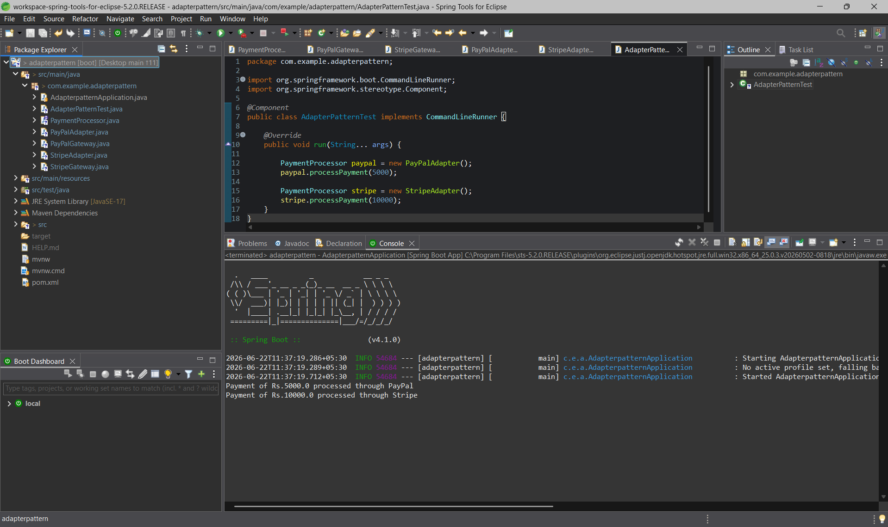

Exercise 5: Implementing the Decorator Pattern
Scenario:
You are developing a notification system where notifications can be sent via multiple channels (e.g., Email, SMS). Use the Decorator Pattern to add functionalities dynamically.
Steps:
- Create a New Java Project:
  - Create a new Java project named DecoratorPatternExample.
- Define Component Interface:
  - Create an interface Notifier with a method send().
- Implement Concrete Component:
  - Create a class EmailNotifier that implements Notifier.
- Implement Decorator Classes:
  - Create abstract decorator class NotifierDecorator that implements Notifier and holds a reference to a Notifier object.
  - Create concrete decorator classes like SMSNotifierDecorator, SlackNotifierDecorator that extend NotifierDecorator.
- Test the Decorator Implementation:
  - Create a test class to demonstrate sending notifications via multiple channels using decorators.

OUTPUT :

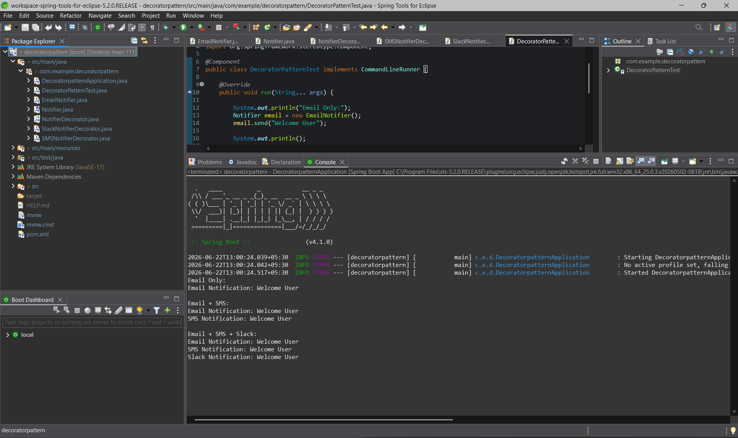

Exercise 6: Implementing the Proxy Pattern
Scenario:
You are developing an image viewer application that loads images from a remote server. Use the Proxy Pattern to add lazy initialization and caching.
Steps:
- Create a New Java Project:
  - Create a new Java project named ProxyPatternExample.
- Define Subject Interface:
  - Create an interface Image with a method display().
- Implement Real Subject Class:
  - Create a class RealImage that implements Image and loads an image from a remote server.
- Implement Proxy Class:
  - Create a class ProxyImage that implements Image and holds a reference to RealImage.
  - Implement lazy initialization and caching in ProxyImage.
- Test the Proxy Implementation:
  - Create a test class to demonstrate the use of ProxyImage to load and display images.

OUTPUT :
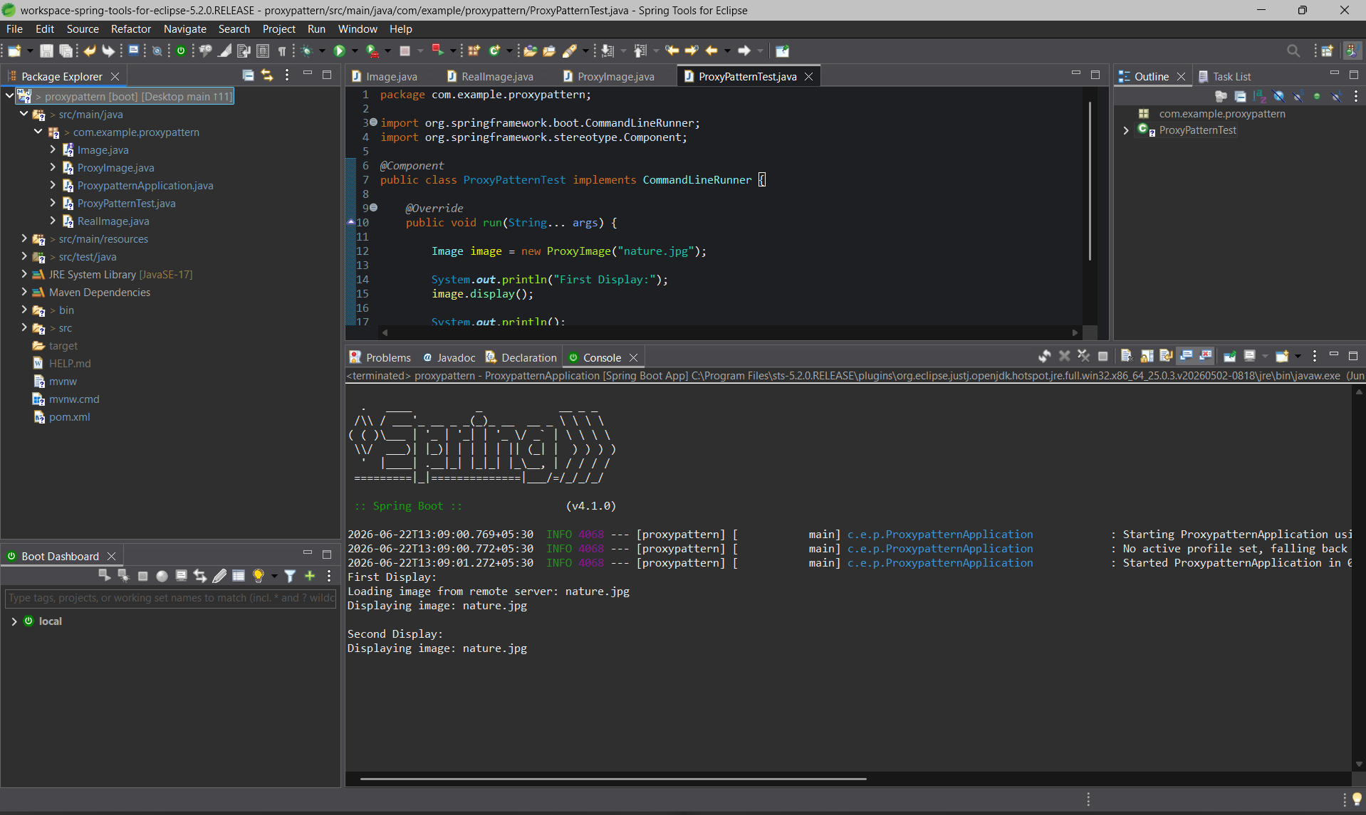

Exercise 7: Implementing the Observer Pattern
Scenario:
You are developing a stock market monitoring application where multiple clients need to be notified whenever stock prices change. Use the Observer Pattern to achieve this.
Steps:
- Create a New Java Project:
  - Create a new Java project named ObserverPatternExample.
- Define Subject Interface:
  - Create an interface Stock with methods to register, deregister, and notify observers.
- Implement Concrete Subject:
  - Create a class StockMarket that implements Stock and maintains a list of observers.
- Define Observer Interface:
  - Create an interface Observer with a method update().
- Implement Concrete Observers:
  - Create classes MobileApp, WebApp that implement Observer.
- Test the Observer Implementation:
  - Create a test class to demonstrate the registration and notification of observers.

OUTPUT :
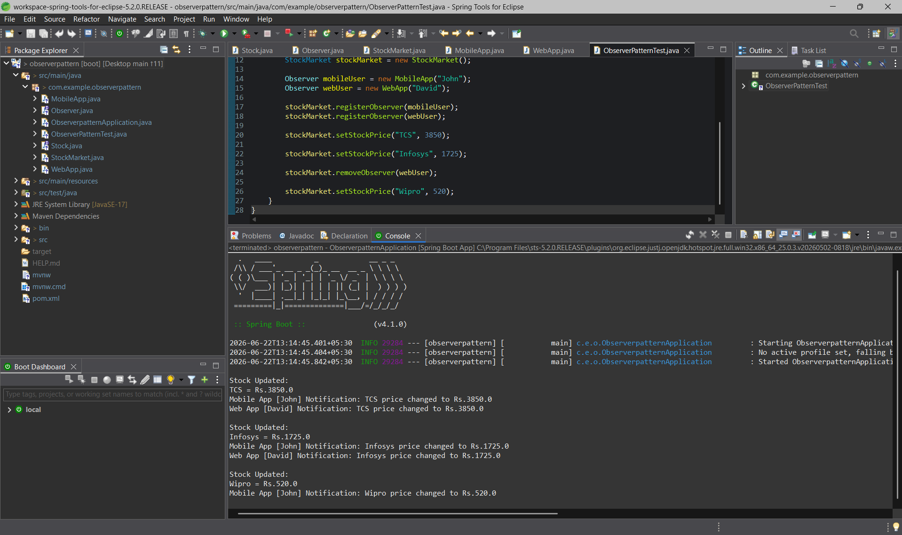

Exercise 8: Implementing the Strategy Pattern
Scenario:
You are developing a payment system where different payment methods (e.g., Credit Card, PayPal) can be selected at runtime. Use the Strategy Pattern to achieve this.
Steps:
- Create a New Java Project:
  - Create a new Java project named StrategyPatternExample.
- Define Strategy Interface:
  - Create an interface PaymentStrategy with a method pay().
- Implement Concrete Strategies:
  - Create classes CreditCardPayment, PayPalPayment that implement PaymentStrategy.
- Implement Context Class:
  - Create a class PaymentContext that holds a reference to PaymentStrategy and a method to execute the strategy.
- Test the Strategy Implementation:
  - Create a test class to demonstrate selecting and using different payment strategies.

OUTPUT :
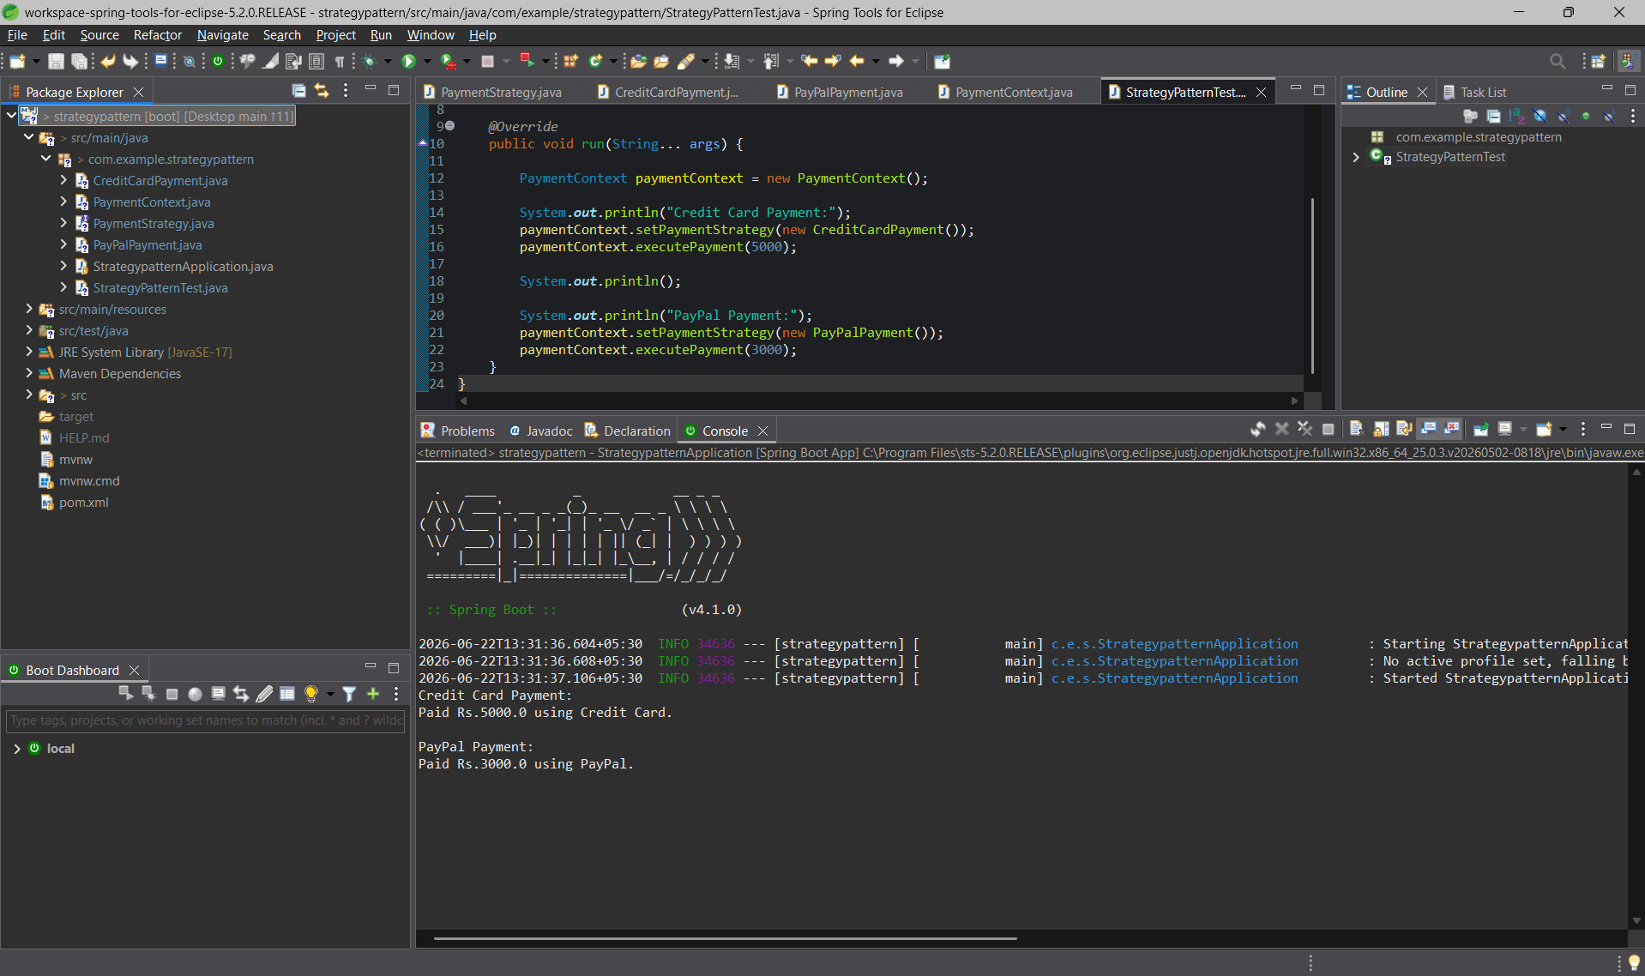

Exercise 9: Implementing the Command Pattern
Scenario: You are developing a home automation system where commands can be issued to turn devices on or off. Use the Command Pattern to achieve this.
Steps:
- Create a New Java Project:
  - Create a new Java project named CommandPatternExample.
- Define Command Interface:
  - Create an interface Command with a method execute().
- Implement Concrete Commands:
  - Create classes LightOnCommand, LightOffCommand that implement Command.
- Implement Invoker Class:
  - Create a class RemoteControl that holds a reference to a Command and a method to execute the command.
- Implement Receiver Class:
  - Create a class Light with methods to turn on and off.
- Test the Command Implementation:
  - Create a test class to demonstrate issuing commands using the RemoteControl.
Exercise 10: Implementing the MVC Pattern
Scenario:
You are developing a simple web application for managing student records using the MVC pattern.
Steps:
- Create a New Java Project:
  - Create a new Java project named MVCPatternExample.
- Define Model Class:
  - Create a class Student with attributes like name, id, and grade.
- Define View Class:
  - Create a class StudentView with a method displayStudentDetails().
- Define Controller Class:
  - Create a class StudentController that handles the communication between the model and the view.
- Test the MVC Implementation:
  - Create a main class to demonstrate creating a Student, updating its details using StudentController, and displaying them using StudentView.

Exercise 11: Implementing Dependency Injection
Scenario:
You are developing a customer management application where the service class depends on a repository class. Use Dependency Injection to manage these dependencies.
Steps:
- Create a New Java Project:
  - Create a new Java project named DependencyInjectionExample.
- Define Repository Interface:
  - Create an interface CustomerRepository with methods like findCustomerById().
- Implement Concrete Repository:
  - Create a class CustomerRepositoryImpl that implements CustomerRepository.
- Define Service Class:
  - Create a class CustomerService that depends on CustomerRepository.
- Implement Dependency Injection:
  - Use constructor injection to inject CustomerRepository into CustomerService.
- Test the Dependency Injection Implementation:
  - Create a main class to demonstrate creating a CustomerService with CustomerRepositoryImpl and using it to find a customer.

